Name: ­­­­­­­_______________________ Date: __________________

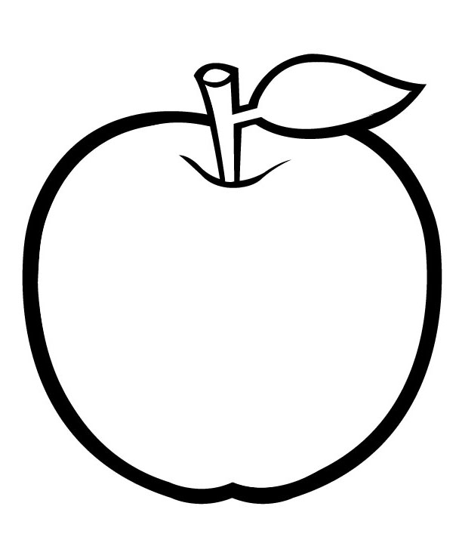Directions: Color in the percentage of Earth’s land that you think we are able to grow healthy plants on

# Shake and Wait: Observing a Soil Sample

**Directions:** Looking at the soil sample you brought in your plastic bag, write some observations about your soil sample. Example: What color is it, where did it come from, what type of objects can you see, etc.

# What Soil Is This?

**Observations:** ______________________________________________________________________________________________________________________________________________________________________________________________________________________________________________________________________________________________________________________________________________________________________________________________________________________________________________________________________________________________________________________________

***Note:*** *Remember that soils have a combination of sand, silt, and clay. Some soils have more of one texture than the other.*

**Looking at your soil sample what texture do you think is makes up your soil the most?**

______________________________________

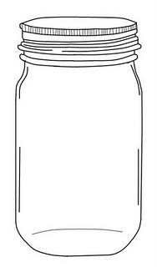

What soil texture do you think is in the top, middle, and bottom layers of the jar? *(sand, silt, or clay)?*

**Texture Locations** **Measurement**

Top: ____________________ __________ cm (centimeters)

Middle: ____________________ __________ cm

Bottom: ____________________ __________ cm

**Directions:** After day 3 of letting your jar sit, draw what you see in your jar on the jar below.